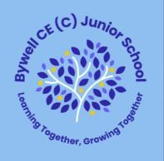

Year 3 Orange Words

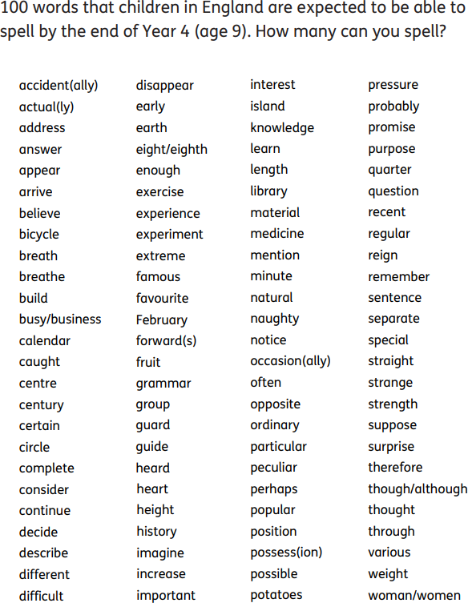

56 words that children in England are expected to be able to spell by the end of Year 3. How many words can you spell?