Spelling Word | Practise 1  (copy into space) | Practise 2  (copy again) | Practise 3  (fold and hide) | Can spell word  (check and correct)
incorrect
independent
infrequent
invisible
dangerous
enormous
fabulous
generous

Pyramid spelling technique
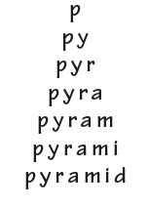
This method of learning words forces you to think of each letter separately.

