Spelling Word | Practise 1  (copy into space) | Practise 2  (copy again) | Practise 3  (fold and hide) | Can spell word  (check and correct)
school
character
echo
chemist
scheme
chaos
orchestra
stomach
chorus
anchor
mechanic
ache

Pyramid spelling technique
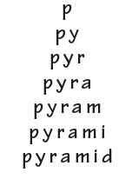
This method of learning words forces you to think of each letter separately.

