Spelling Word | Practise 1  (copy into space) | Practise 2  (copy again) | Practise 3  (fold and hide) | Can spell word  (check and correct)
brochure
chalet
chandelier
charade
chef
chute
machine
moustache
parachute

Pyramid spelling technique
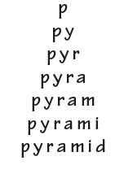
This method of learning words forces you to think of each letter separately.

